Addition: Hi everybody! This was actually a homework assignment for one of my classes, but I thought it went well with the theme of this blog. Enjoy my exploration into future of Moore’s Law and Dennard’s Scaling!

**Nanotechnology (APh 180) Homework 3**

Dennard’s scaling suggests that as transistors get smaller, voltage and current decrease, but power density stays constant. This is beautiful since it implies that amount of power per unit volume does not get sacrificed at microscopic scales. However, when looking at the Figure 1 below (provided in the homework statement), we notice that the typical power seems to plateau around 2006, despite increasing the number of transistors. This catapulted research into multicore architectures, since it suggested that Dennard’s scaling no longer held. I believe Dennard’s scaling broke down because of the architecture of electronics. Here, we are limited to a binary system – there is only an ON and OFF system, an exclusive choice. Perhaps this is the reason why transistors can no longer output the same power. The code with which we are writing information (1’s and 0’s) is too restrictive.

To continue, there are some physical limitations when going small. For example, thermal management or heat removal are physically constrained conditions. Although using less power supports going smaller, heat removal is a function of thermal conductivity, which is a material physical property barrier to going smaller. Without sufficient heat removal, the electronics will overheat. Active cooling (Peltier effect) has been used to push this boundary. This is a major reason for the asymptotic behavior of Moore’s law.

Moore’s law proposes that the number of transistors in a chip doubles roughly every two years. It does indeed seem that the rates of doubling using classic transistor design is coming to a halt, as suggested by Jensen Huang (cited from the homework statement). This does not necessarily mean that Moore’s law is forever compromised. Instead, it should open our eyes to consider other systems that can help us preserve Moore’s law and continue miniaturizing microchips.

Imaging the plethora of possibilities that could arise if we had four degrees of freedom instead of two. This would require a fundamental restructuring of the way transistors are made. This could allow us to code more information in the same amount of space, thereby allowing power density and transistor numbers to continue increasing without impacting the physical constraints of heat removal. Enter an easy solution: DNA! In my opinion, DNA in conjunction with semiconductors will unlock doors to a variety of electronics applications. It is the future of both electronics and biology. The aforementioned four degrees of freedom comes from the nucleotides that make up DNA: adenine, cytosine, guanine, and thymine, often referred to as ACGT.

Current electronic circuits are based on binary logic inputs. In order to code a number, like 20, you need “10100” with binary systems. With DNA however, this could theoretically be written as “CG”, already reducing storage space by more than 2x. Note that this is not an established standard but instead an example to demonstrate a possibility. With ACGT, there are more permutations and combinations that can be used to code more information in less space.

One concern with this proposal is the ability to create multicore architectures. Seems problematic right? But alas nature has evolved in such an elegant way that we can steal designs that work efficiently. We can create biomimetic processes modeled after proton gradient-aided transport. According to techopedia, “multicore refers to an architecture in which a single physical processor incorporates the core logic of more than one processer. A single integrated circuit is used to package or hold these processors” 1. A visual depiction of this is shown in Figure 2 2.

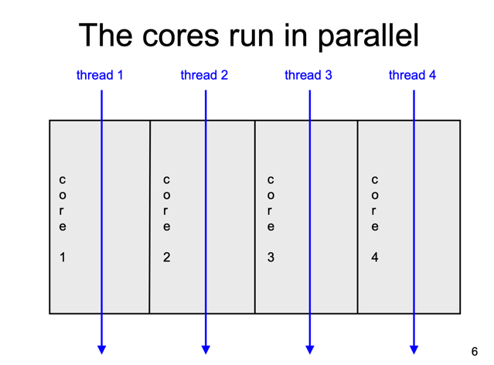

Figure 2 Multicore architecture as explained in electronics today 2

We can simply recreate this with components from nature. This is best explained with a diagram, as shown in Figure 3.

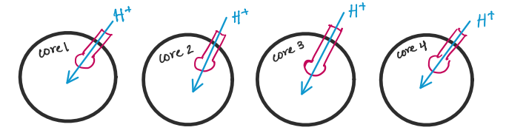

Figure 3 Proposed multicore architecture using natural systems. The black circles represent liposomes. The pink shapes represent proton pumps (such as ATP synthase). The blue lines indicate the direction of protons, which can be used to control the threads.

In this proposed approach, we can use synthetic cells, also known as vesicles, as our outer structure. Synthetic cells can be customized to contain the bare-minimum components. These synthetic cells can be used as living and evolving environments in which more complex engineered systems can be implemented and designed 3. By developing a programmable chassis which we understand completely, it will be easier to repurpose biochemical circuitry to do a variety of tasks. It is important that the synthetic cells do not replicate or divide, since this allows us to control whether the organisms enter our biosphere. We can instead build biochemical machines that will die after performing the desired task. Further, we can use membrane proteins that require proton gradients, such as ATP synthase, to turn off/on and control how fast a thread functions. Here, we may be limited by the speed at which protons tend to travel through ATP synthase, a bit faster than 3 protons per second. By harnessing concepts from diffusion and active transport however, we may be able to increase the rate of transport. This idea allows for miniaturization, since we are in the 10 nm order of magnitude, and simultaneously grants an opportunity to store more information in less space.

All in all, there are many details that still need to be ironed out to make this a viable pursuit. However, with adequate planning and collaboration between biologists and electrical engineers, I can see this design coming to fruition! Think about all the information a human brain can store – all because of the genetic code of life, DNA. Thus, I believe we can exploit these natural tools for our own benefit in a new field of genetic-electronics!

P.S. There’s another potential entirely to use DNA **as** the actual semiconductor material. But that’s a topic for another time.

Works Cited

1. <https://www.techopedia.com/definition/5305/multicore#:~:text=Multicore%20refers%20to%20an%20architecture,package%20or%20hold%20these%20processors.&text=Multicore%20architecture%20places%20multiple%20processor,as%20a%20single%20physical%20processor>.
2. <https://www.cs.cmu.edu/~fp/courses/15213-s06/lectures/27-multicore.pdf>
3. Richard M. Murray, *Toward Genetically Programmed Synthetic Cells and Multi-Cellular Machines*. <http://www.cds.caltech.edu/~murray/talks/murray_buildacell-pasadena_24Jul17.pdf>